|  |  |
| --- | --- |
|  | Faculty of Information Science and Technology  Universiti Kebangsaan Malaysia  43600 Bangi Selangor |
| **TTTK2103**  **Computer Network Technology** | |

**PACKET TRACER**

2.3.7 Packet Tracer - Navigate the IOS

2.3.8 Packet Tracer - Navigate the IOS Using a Terminal Client

for Console Connectivity - Physical Mode

|  |  |
| --- | --- |
| **Name** | **Matrix Number** |
| Mariam binti Masuan | A182976 |
| Mohamad Saiful Nizam bin Abd Aziz | A179830 |

**2.3.7 Packet Tracer - Navigate the IOS**

## Establish Basic Connections, Access the CLI, and Explore Help

**Step 2: Establish a terminal session with S1.**

**b. What is the setting for bits per second?**

Answer: 9600

**d. What is the prompt displayed on the screen?**

Answer: S1>

**Step 3: Explore the IOS Help.**

a. Which command begins with the letter ‘C’?

Answer: connect

**b. Which commands are displayed?**

Answer: telnet terminal traceroute

**Which commands are displayed?**

Answer: telnet terminal

## Enter privileged EXEC mode.

**Step 1: Enter privileged EXEC mode.**

**a. What information is displayed that describes the enable command?**

Answer: Turn on privileged commands

**b. What displays after pressing the Tab key?**

Answer: enable

**What would happen if you were to type te<Tab> at the prompt?**

Answer: ‘te’ does not provide enough characters to make the command unique so the characters will continue to display prompting the user for additional characters to make the command unique. There is more than one command that begins with the letters ‘te’.

**c. Enter the enable command and press ENTER. How does the prompt change?**

Answer: It changes from S1> to S1# indicating Privileged EXEC mode.

**d..Previously in user EXEC mode there was one command that started with the letter ‘C’. Now how many commands are displayed that begin with the letter ‘C’? (Hint: you could type c? to list just the commands beginning with ‘C’.)**

Answer: There are 5 commands that begin with ‘C’: clear clock configure connect copy

**Step 2: Enter Global Configuration mode**

**a. What is the message that is displayed?**

Answer: Configuring from terminal, memory, or network [terminal]?

**b. Press the <ENTER> key to accept the default parameter enclosed in brackets [terminal].How does the prompt change?**

Answer: S1(config)#

**c. S1(config)# exit**

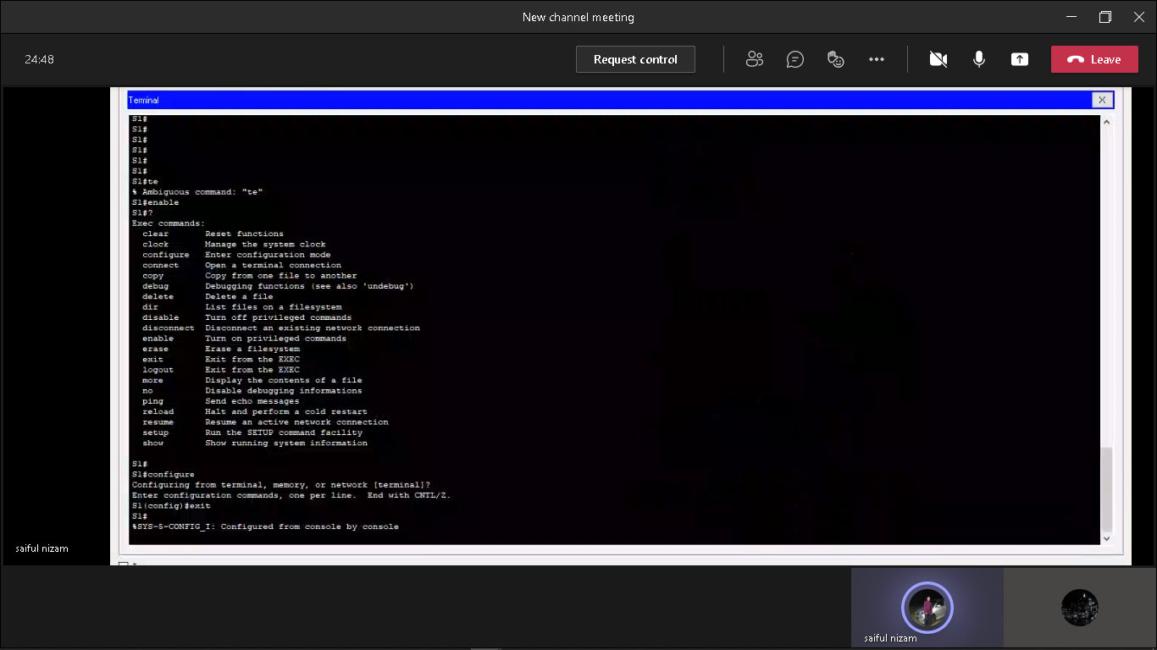**S1#**

## Set the Clock

**Step 1: Use the clock command.**

**a. What information is displayed? What is the year that is displayed?**

Answer: *13:36:7.906 UTC Mon Mar 1 1993

**b. S1# clock<ENTER>**

**What information is displayed?**

Answer: % Incomplete command

**c. S1# clock ?**

**What information is displayed?**

Answer: set Set the time and date

**d. S1# clock set ?**

**What information is being requested?**

Answer: hh:mm:ss Current time

**What would have been displayed if only the clock set command had been entered, and no request for help was made by using the question mark?**

Answer: % Incomplete command

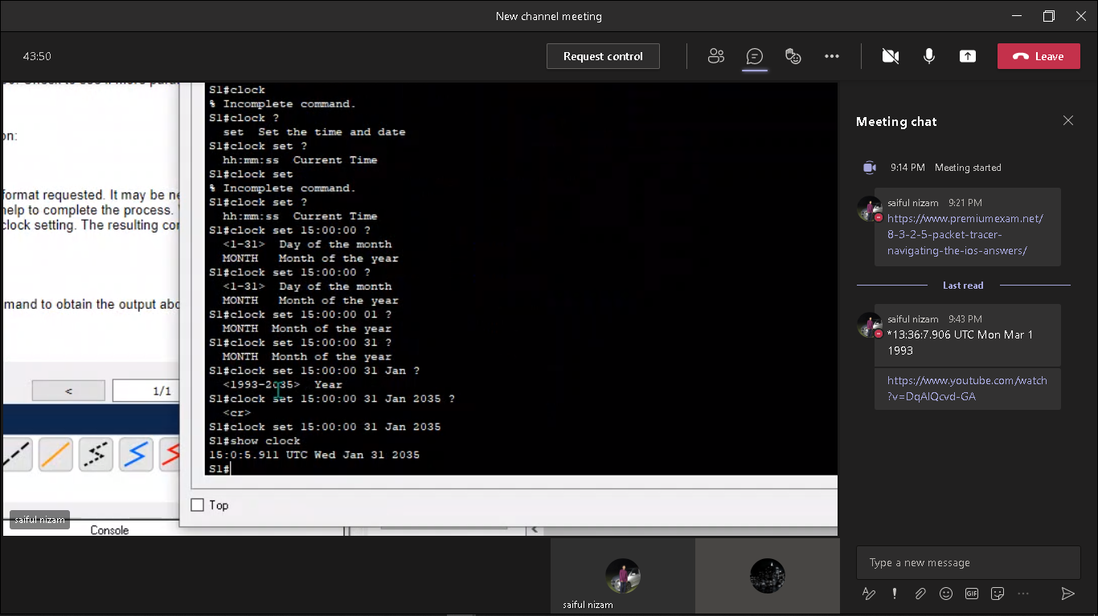

**Step 2: Explore additional command messages.**

**b. S1# cl<tab>**

**What information was returned?**

Answer: S1#cl

**S1# clock**

**What information was returned?**

Answer: % Incomplete command

**S1# clock set 25:00:00**

**What information was returned?**

Answer: % Invalid input detected at ‘^’ marker. (at 25)

**S1# clock set 15:00:00 32**

**What information was returned?**

Answer: % Invalid input detected at ‘^’ marker. (at 32)

**2.3.8 Packet Tracer - Navigate the IOS Using a Terminal Client**

**Part 1: Access a Cisco Switch through the Serial Console Port**

**Step 1: Install and investigate a 2960 switch.**

Inspect Front:

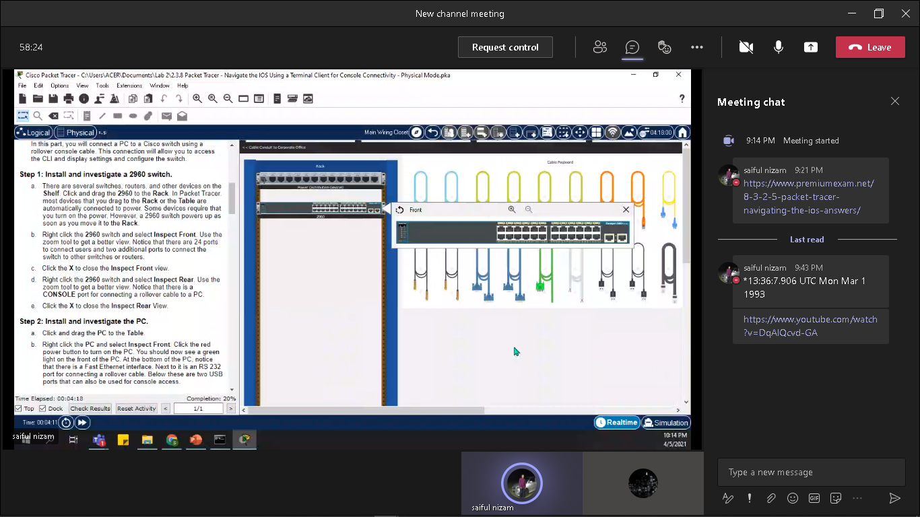

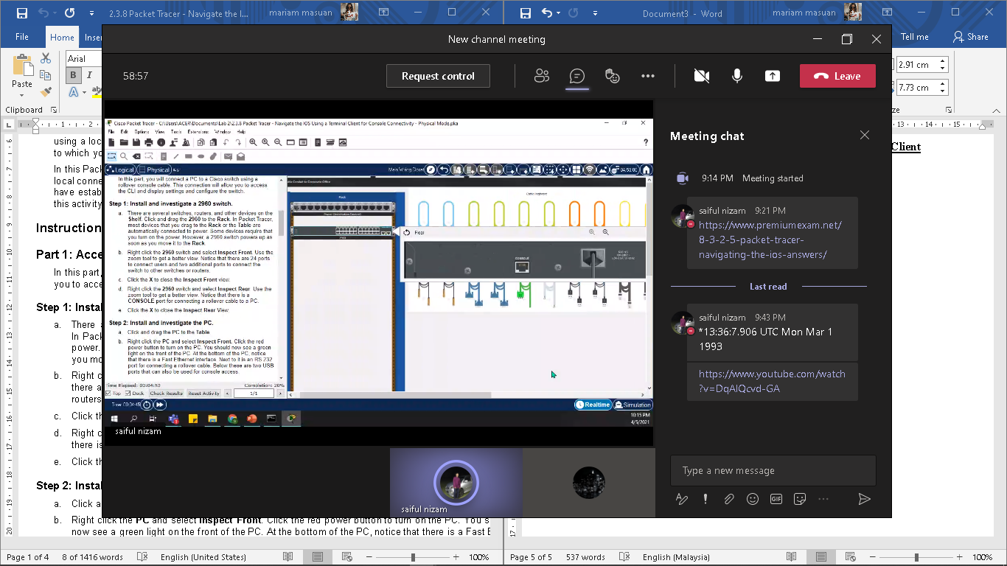 Inspect Rear:

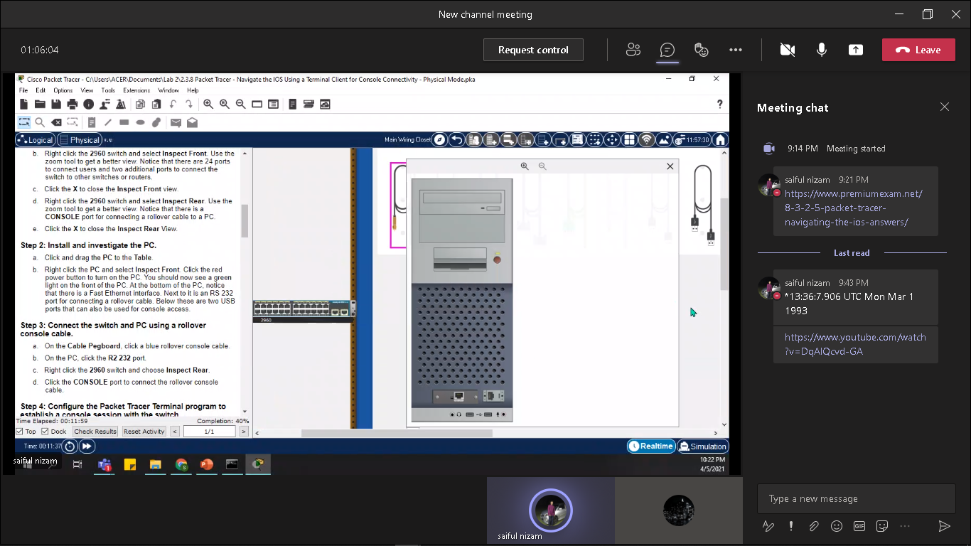 **Step 2: Install and investigate the PC.**

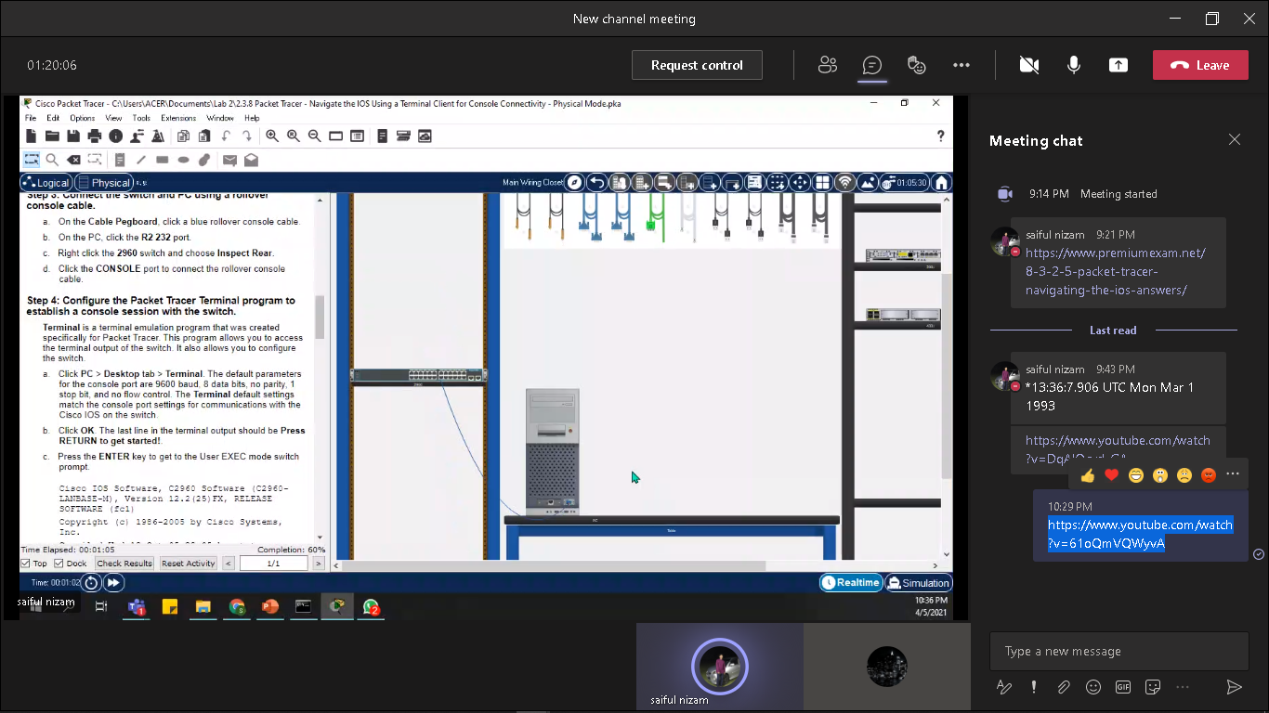 **Step 3: Connect the switch and PC using a rollover console cable.**

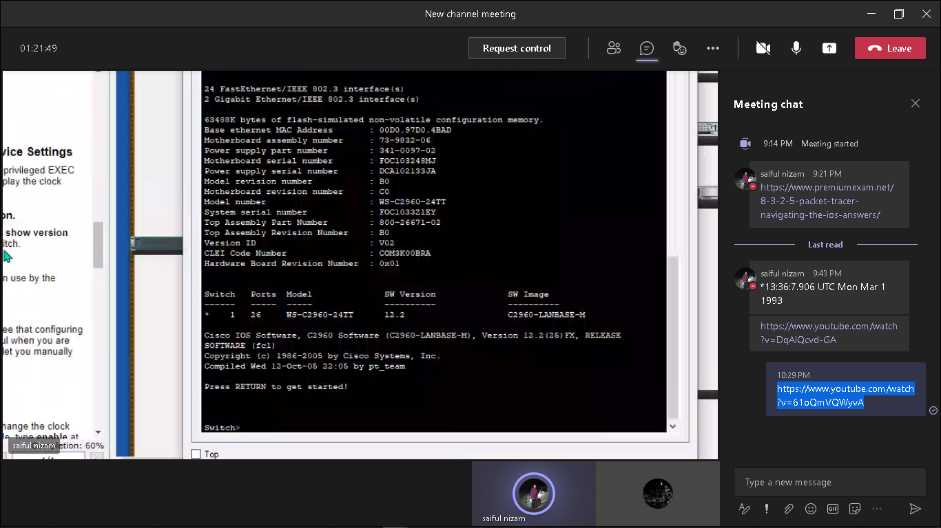**Step 4: Configure the Packet Tracer Terminal program to establish a console session with the switch.**

**Part 2: Display and Configure Basic Device Settings**

**Step 1: Display the switch IOS image version.**

**Switch> show version**

**Which IOS image and version is currently in use by the switch?**

Answer: C2960 Software (C2960-LANBASE-M), Version 12.2(25) FX

**Step 2: Configure the clock.**

1. **Display the current clock settings.**

**Switch> show clock**

**\*00:30:05.261 UTC Mon Mar 1 1993**

Answer: *0:9:53.769 UTC Mon Mar 1 1993

1. **You must be in privileged EXEC mode to change the clock settings. To enter the privileged EXEC mode, type enable at the user EXEC mode prompt.**

**Switch> enable**

Answer: Switch#

1. 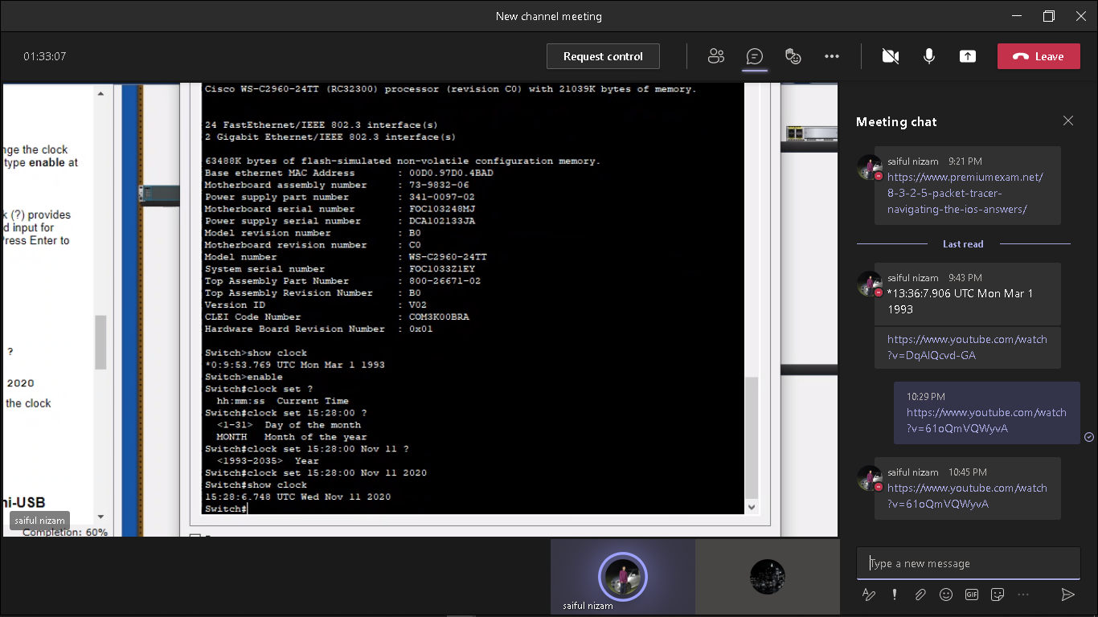**d.**

**Part 3: Access a Cisco Router Using a Mini-USB Console Cable**

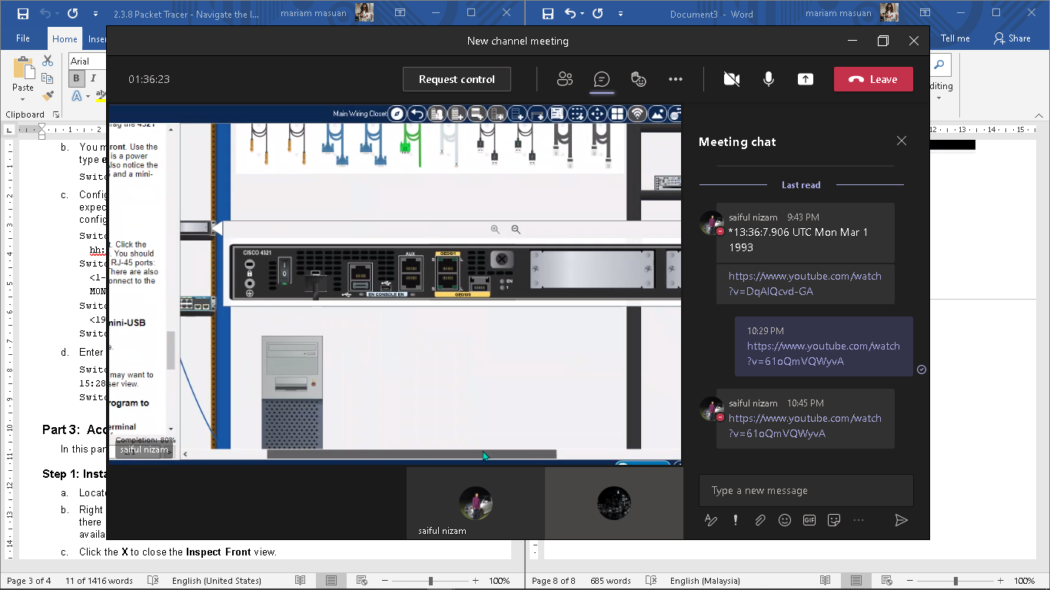 **Step 1: Install and investigate a 4321 router.**

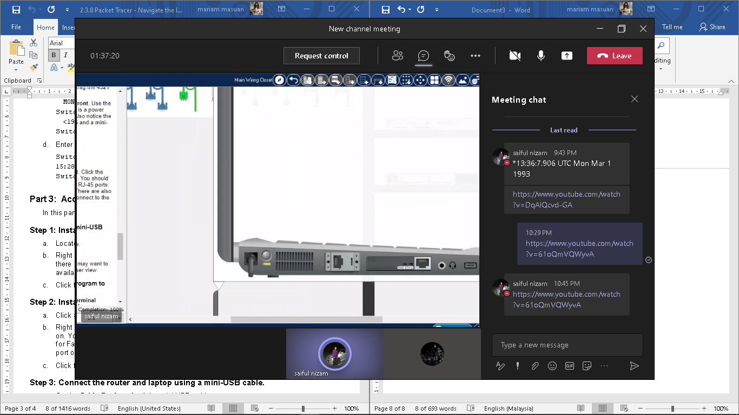 **Step 2: Install and investigate the Laptop.**

**Step 3: Connect the router and laptop using a mini-USB cable.**

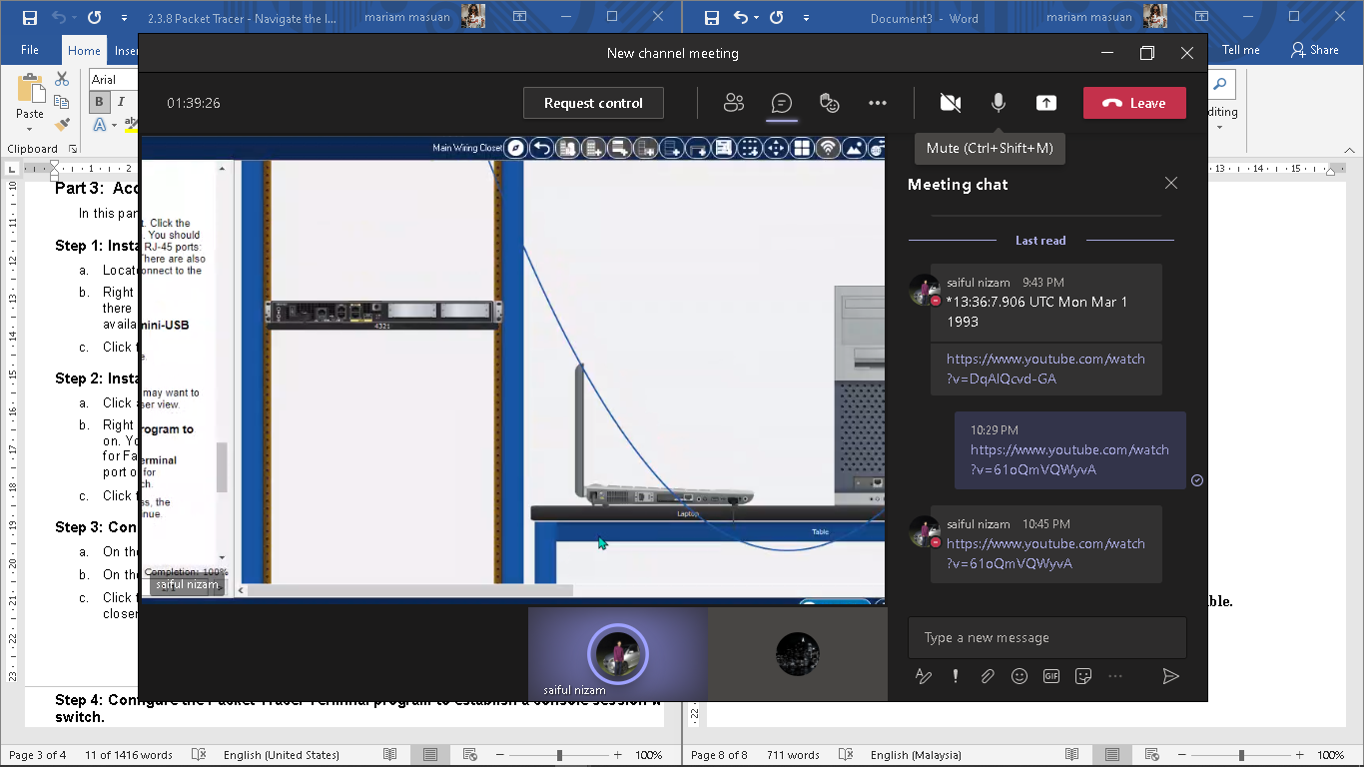

**Step 4: Configure the Packet Tracer Terminal program to establish a console session with the switch.**

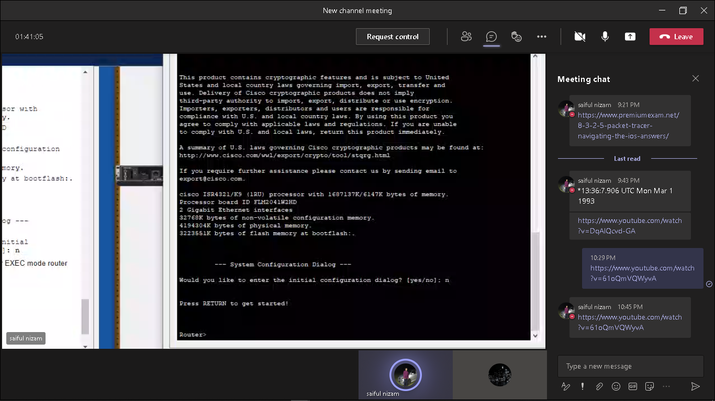

**Reflection Question**

**1.How do you prevent unauthorized personnel from accessing the Cisco device through the console port?**

Answer: Physically secure the device and use password protection

**2.What are the advantages and disadvantages of using the serial console connection compared to the USB console connection to a Cisco router or switch?**

Answer: It depends on the port availability on the PC and the router or switch. If the PC has a serial port and a DB9-to-RJ45 cable is available, it is generally easier to connect to the router or switch using the serial console port. If the PC does not have a serial port, a third-party USB-to-Serial adapter can be used. Cisco switches do not have mini-USB console ports, so connecting via USB is not an option. If you are frequently connecting to a Cisco router that has a mini USB console port, this can be the most effective method after the Cisco drivers are installed because nearly all newer PCs have USB ports.